FIGURE SKATING IN HARELM
FY 2022 PRESS KIT
Contact: Alex Wasch
VP, Strategic Partnerships
361 West 125th Street, 4th Floor
New York, NY 10027
646.698.3440 ext. 110
alex@figureskatinginharlem.org
www.figureskatinginharlelm.org
MISSION/VISION
Figure Skating in Harlem’s (FSH) mission is to help girls transform their lives and grow in confidence, leadership and academic achievement. We are the only organization for girls of color that combines the power of education with access to the artistic discipline of figure skating to build champions in life.
FSH began twenty fives years ago with a vision to empower young girls in the Harlem community. Our hope is that through each student’s experience, she will graduate our program as a powerful speaker, effective leader, and global citizen. As we expand in Detroit, with the launch of our new chapter Figure Skating in Detroit, we hope to bring the benefits of our model education and skating based program to even more children!
PROGRAM CRITERIA
Figure Skating in Harlem offers year-round academic, leadership and skating programs for girls ages 6-18. All students must reside in Harlem, Upper Manhattan or the lower Bronx. In New York, all FSH students make a commitment to aim for an “A” average, are in good standing with a “B” average and must attend extra homework tutoring with a “C” average. We also serve a cohort of students in Detroit.
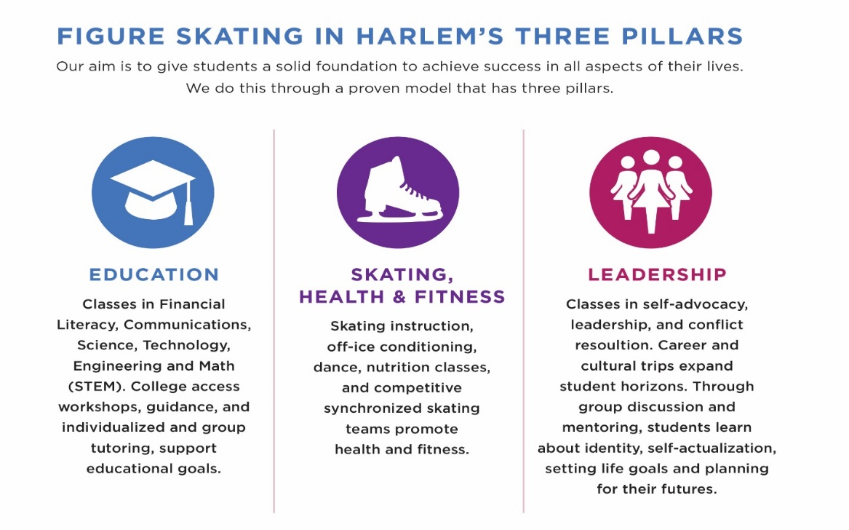

OUR PROGRAMS
I Can Excel (ICE) is our premiere after-school program that improves student academics, encourages active lifestyles through figure skating and fitness classes, and strengthens leadership skills. At the start of every season, each girl makes a commitment to attend 9-15 hours per week of on-ice instruction at our home rink at Riverbank State Park, and off-ice educational programming at our Academic Center on 125th Street, and receives the support of more than 60 tutors, teachers, social workers, counselors and skating coaches.
Figure Skating in Harlem has instilled confidence in me and helped me believe that I can do anything that I want to do. – Destiny Jean-Michel, FSH Senior
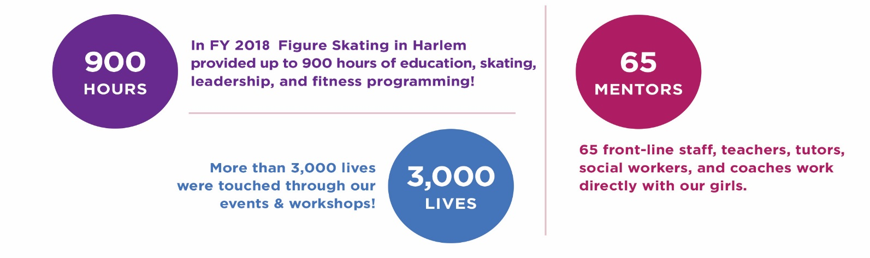
Our popular Summer Dreams Camp runs for 6 weeks in July and August for a total of 35 hours per week. Our students enjoy a daily variety of academic enrichment classes and cultural trips followed by on-ice skating instruction.
OUR HISTORY
Founded in 1997 as a response to a direct need in the Harlem community, Figure Skating in Harlem established itself as a safe space for young girls to achieve academic excellence and physical well-being through the lens of figure skating. Founder and CEO, Sharon Cohen heard this call to action in the early 90’s when she was invited by community leaders Gene Kitt and Bernice DeAbreu to teach a group of girls on the ice at Upward, Inc., an East Harlem community organization. “I witnessed first-hand the difference skating made in the lives of these young girls,” Cohen said, “They beamed with pride as they experienced their progress. There was nothing like it!”
After collaborating with Upward, Inc. for more than 6 years, Cohen saw that the demand for a skating enriched education program grew well beyond their walls. With tremendous support from the community and parents, Figure Skating in Harlem was incorporated as a non-profit 501(c)(3). What started out with a handful of girls and a dream to figure skate, soon became a leading girls empowerment organization; the first ever to combine rigorous academic support, with leadership development, and access to the artistic discipline of figure skating.

FSH PRAISE
“To see these amazing girls, become amazing women, and do wonderful things for all of us, is incredible.”
- Michael “Coach K” Krzyzewski, Head Men’s Basketball Coach at Duke University
“Figure Skating in Harlem is a quintessential New York organization. It's about achievement, excellence and community." - Vera Wang, Fashion Designer
“It’s exciting to see the young girls, many of whom are getting out on the ice for the first time. Whether you are learning to skate or learning a new move, you fall and have to pick yourself up. You learn to appreciate your own ability.” – Meryl Davis, Olympic Champion
Programs like this are needed in every city in the United States. It’s amazing how many young people just need that opportunity, and we need to support it in every possible way.
– Scott Hamilton, Skating Icon & Humanitarian
"You put wings on their feet, which become wings on their hearts and wings on their minds - you make it happen" – Gloria Steinem, Activist, Feminist Icon

PHOTOS
Photos are available upon request:
Contact Alex Wasch: alex@figureskatinginharlem.org
